**Turn Partner Dashboard**

**Test Approach**

**Template Version Number: 1.0**

|  |  |  |  |
| --- | --- | --- | --- |
| **Document Approval / Review** | | | |
|  | **Name & Role** | **Signature** | **Date** |
| Author | Oswaldo Barrios Valera |  | 09/10/2017 |
|  |  |  |  |
|  |  |  |  |
|  |  |  |  |
|  |  |  |  |
|  |  |  |  |

|  |  |  |  |
| --- | --- | --- | --- |
| **Version Control** | | | |
| **Version** | **Date** | **Description of Changes** | **Author** |
| 1.0 | 09/10/2017 | New Testing Approach Document for Turn Partner Dashboard | Oswaldo Barrios Valera |
|  |  |  |  |

|  |  |  |  |
| --- | --- | --- | --- |
| **Referenced Documents** | | | |
| **No.** | **Document Title and ID** | **Version** | **Location** |
|  |  |  |  |
|  |  |  |  |

|  |
| --- |
| **Disclaimer** |
| If you are reading a copy of this document (i.e. print out of controlled electronic document or an electronic copy of a wet ink signed paper document) you may be reading an uncontrolled version. Before making updates, please ensure that you are using the latest version of this document and the associated template. |

Contents

1 Introduction 3

1.1 Summary 3

1.2 Purpose 3

1.3 Turn Partner Dashboard Application - General behaviour at 09/10/2017 4

2 Test Scope 9

2.1 Turn Partner Dashboard Application 9

2.1.1 In Scope 9

2.1.2 Out of Scope 9

2.2 Automated Testing Scope 10

2.2.1 In Scope 10

2.2.2 Out of the Scope 10

2.3 Automated Testing Tools 10

2.4 Automation Testing Approach 10

3 Test Approach 12

3.1 Test Scenarios 12

3.2 Risks 13

# Introduction

## Summary

Due the fact that there are no formal requirements for the Turn Partner Dashboard application. The Analysis and test cases design is going to be taken from the general project information page that is available through the following link:

<https://turnhq.github.io/#person-synchronous>

QA team is considering a risk because the information located on above link could be updated at any time and the main purpose of this document is to have an overview of the information contained on it which is being taken on 09/10/2017. To be aware QA team is going to refer to this document as AC (*Acceptance Criteria*) on below sections.

## Purpose

The main purpose of this document is to describe how the QA team is going to manage the existing information for the Turn Partner Dashboard application to analyse, develop and execute the test cases for the coming releases on 2017 year.

A long with that QA team is trying to minimize the risk of having inconsistencies in the future between the test execution and the system behaviour. This will allow us to refer to the specific point of time when the application was tested, the information used to build the test scripts and finally how the test execution was done to provide the QA sign off.

## Turn Partner Dashboard Application - General behaviour at 09/10/2017

Here are the screenshots of the available information for the “Turn Partner Dashboard” application which is the acceptance criteria taken from QA team as the baseline for the analysis, design and execution.

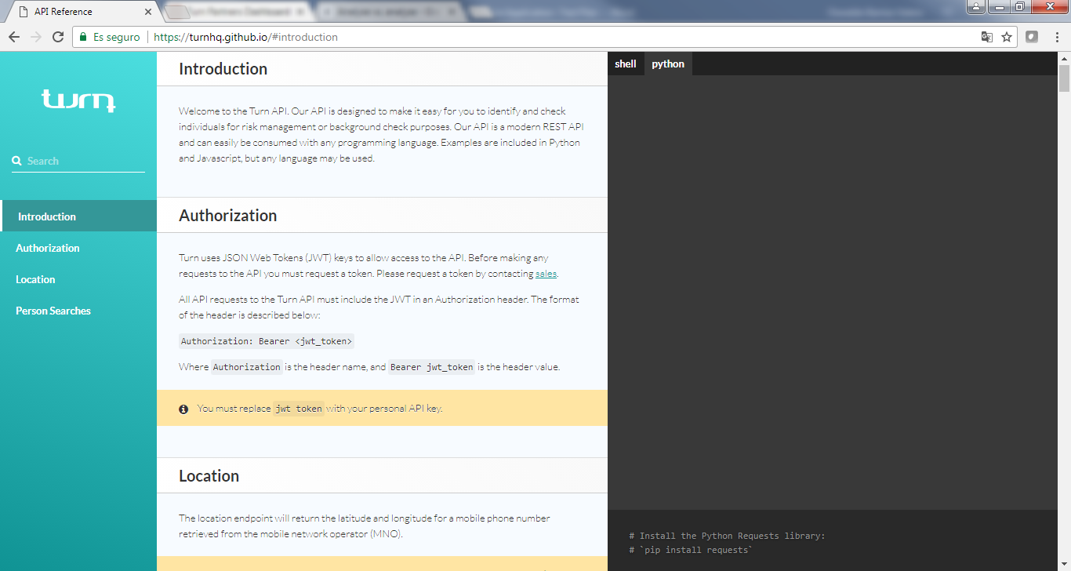

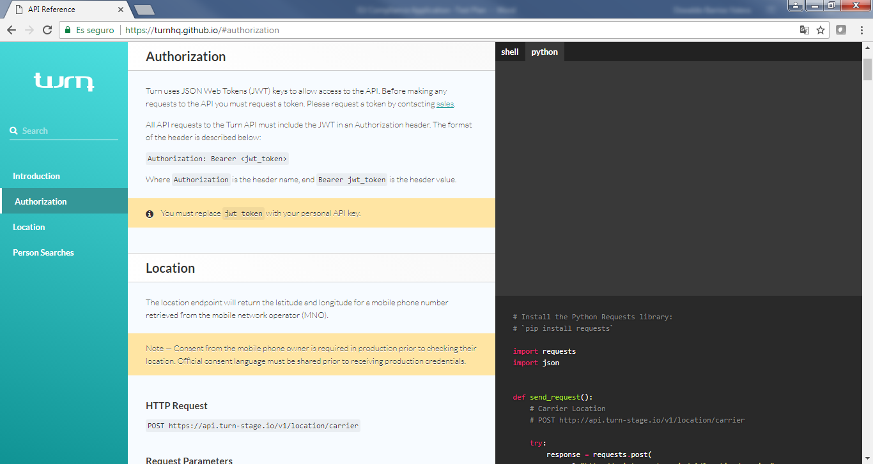

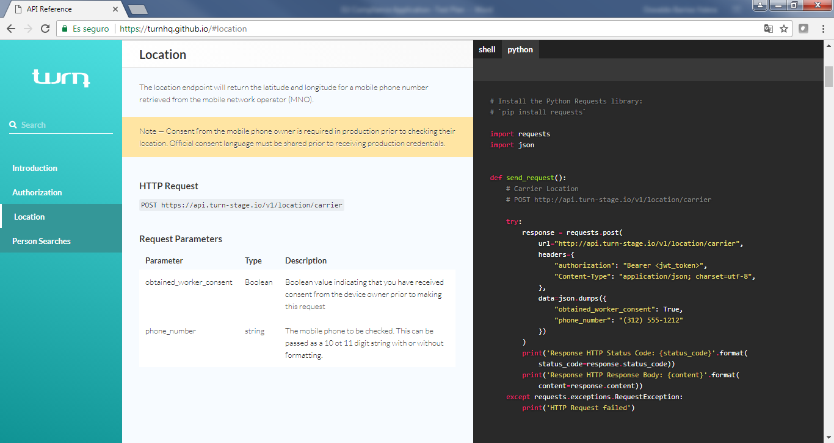

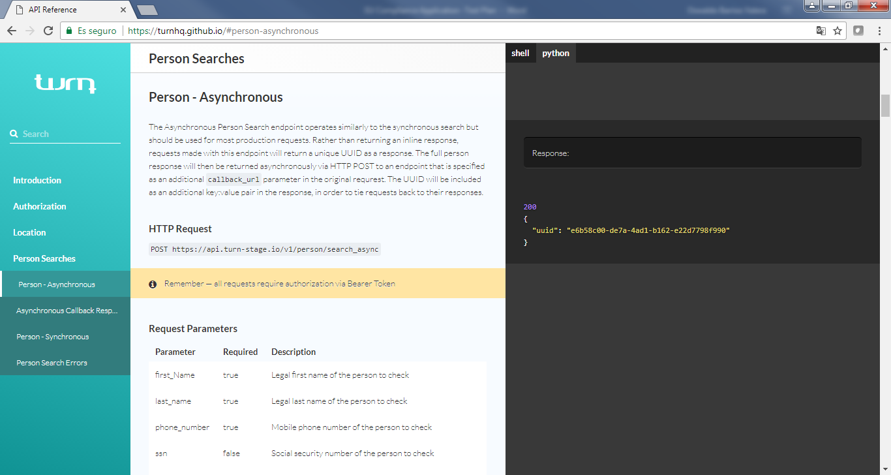

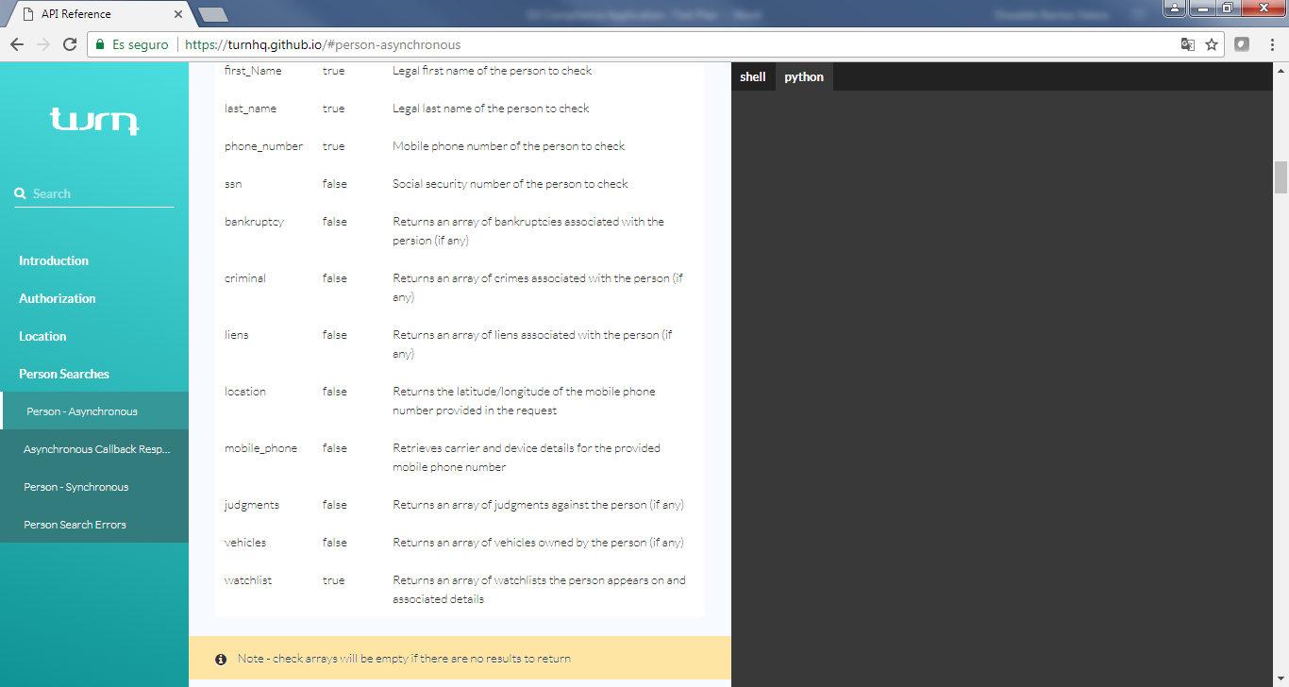

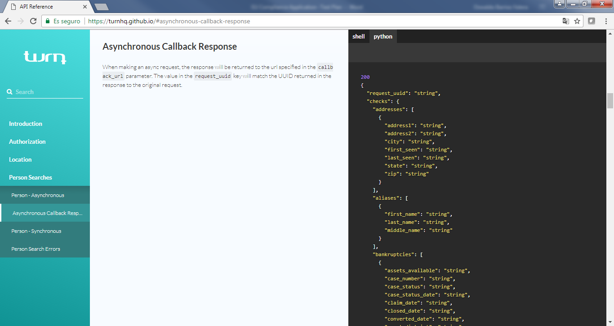

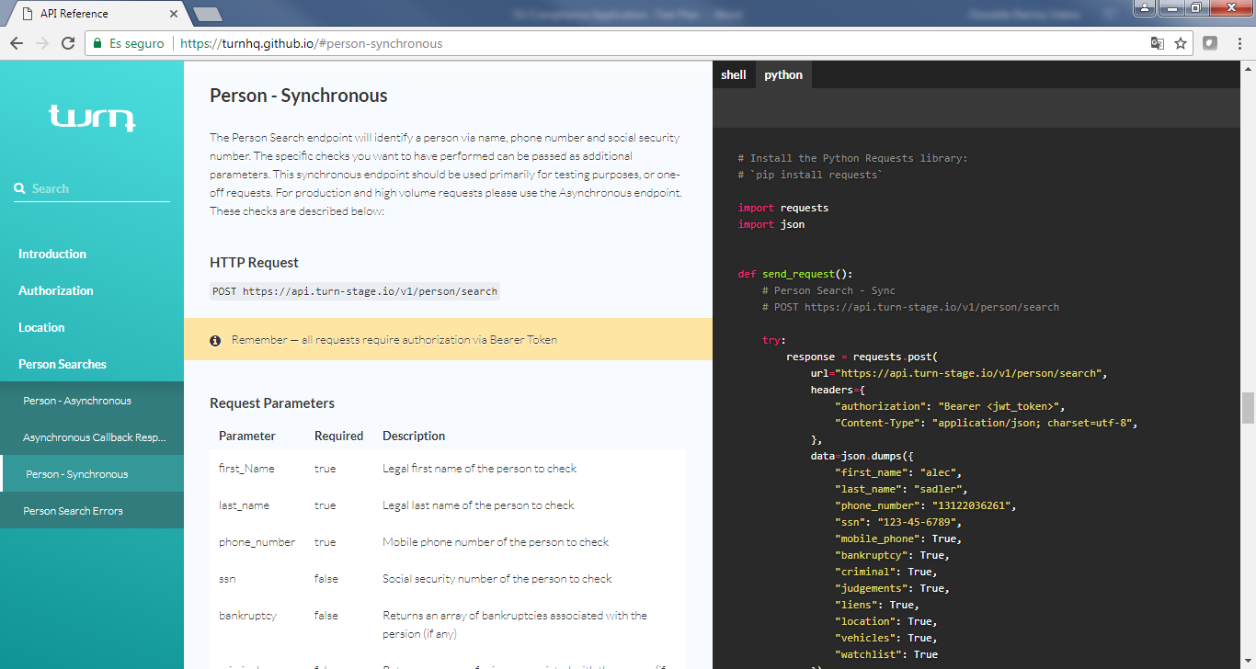

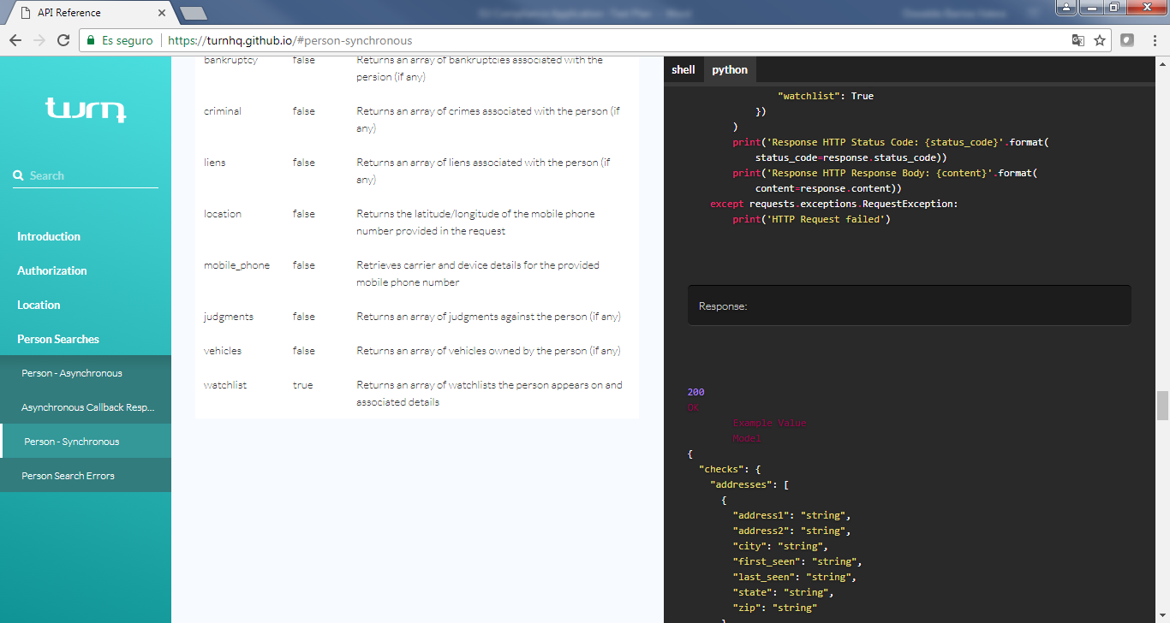

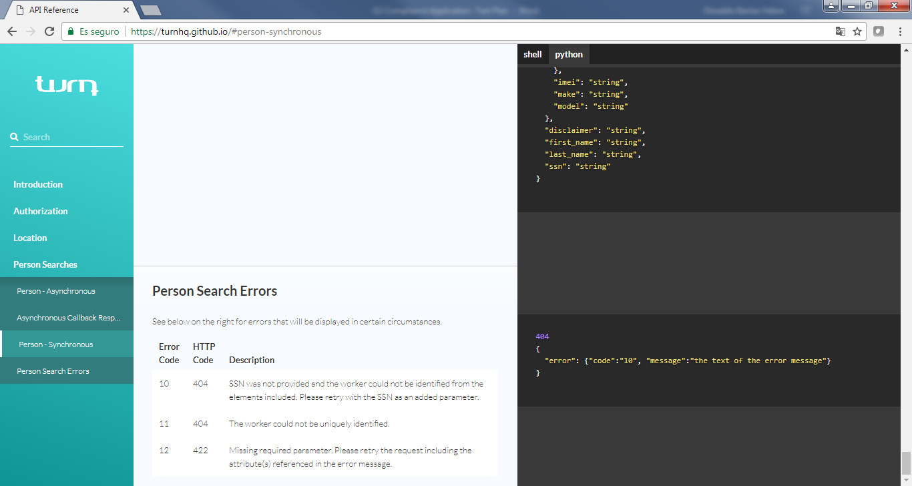

# Test Scope

QA testing team based on the information provided on section 1.3 will analyze and create the test scenarios covering as much as possible

## Turn Partner Dashboard Application

Testing will be performed on the latest versions from IE, Chrome, Safari & Firefox browsers and Mobile platforms like iOs & Android doing cross-check validations between them based on below existing modules:

* Authorization
* Location
* Person Searches
  + Person - Asynchronous
  + Person - Synchronous
  + Person Search Errors
* Log in to Turn application
* Add Candidate – Eligible to create an automated regression suit

### In Scope

* Test the “Add Candidate” functionality on PC and mobile browsers.
  + PC Browsers – IE, Safari, FF & Chrome
  + Mobile Browsers – Android & iOS
* Create an automated regression suite
* User interface
* Error handling validation
* Login with Social media accounts
* Defect tracking

### Out of Scope

* Performance
* Security
* Accessibility
* Testing Data Base
* Testing Web Services
* Automation on mobile devices

## Automated Testing Scope

Automated testing approach will take part of the System/Integration Phase to ensure that the product functions meets with the quality of the structure, content, accuracy and consistency as defined in the project documentation.

Given the “Web Portal” application the QA team will take care to design, execute the automated scrips during the System/Integration phase for below module:

### In Scope

* Add Candidate functionality
* Perform automated scripts on below PC browsers:
  + IE
  + Chrome
  + Safari
  + FF

### Out of the Scope

Mobile Automated scripts (Android & iOS)

## Automated Testing Tools

On this section is mentioned which Automated tool will be used to design, execute the automated scrips including the frameworks as well.

* Selenium Web Driver
* TestNG Framework

## Automation Testing Approach

Below scenarios were selected to run an automated test suit.

|  |  |
| --- | --- |
| **No.** | **Add Candidate - Web Portal application** |
| 21 | TC21_WP_Add candidate with a clean verified profile |
| 27 | TC27_WP_Add a candidate where the Mobile Number field is a VoIP number |
| 28 | TC28_WP_Add a candidate where the Mobile Number field is a landline number |
| 29 | TC29_WP_Add a candidate where the email account is invalid |
| 30 | TC30_WP_Add a candidate where the email account has not the correct format |
| 31 | TC31_WP_Add a candidate where the First Name field is empty |
| 32 | TC32_WP_Add a candidate where the Last Name field is empty |
| 33 | TC33_WP_Add a candidate where the SSN field is empty |

# Test Approach

There are not formal requirements for the current Turn Partner Dashboard and QA team has review and analyse the existing project information to prepare the following test scenarios.

## Test Scenarios

Based on the analysis the following scenarios are in consideration to test the existing Turn Partner Dashboard application. They were send out to the Product Owner for their approval and Review and will be executed manually.

Each one of the below scenarios will be run in all environment mentioned above at the bullet “2.1.1 In Scope”.

|  |  |
| --- | --- |
| **No.** | **Log In page - Web Portal application** |
| 1 | TC01_WP_Create a new Turn candidate from scratch |
| 2 | TC02_WP_Create a new Turn candidate with a Google account from scratch |
| 3 | TC03_WP_Log in with an existing Turn candidate |
| 4 | TC04_WP_Log in with an existing Turn candidate with a Google account |
| 5 | TC05_WP_Log in with a Turn candidate already logged in |
| 6 | TC06_WP_Log in with a Turn candidate different than the one already logged in |
| 7 | TC07_WP_Delete candidate's input information with the "X" symbol |
| 8 | TC08_WP_View candidate's password with the toggle eye password button |
| 9 | TC09_WP_Restore the candidate's password |
| 10 | ~~TC10_WP_Get an error message when is an invalid Turn candidate~~ |
| 11 | ~~TC11_WP_Get an error message when candidate is using and invalid Google account~~ |
| 12 | TC12_WP_Log out from Turn Web Portal application |
| **No.** | **Applicant Section - Web Portal application** |
| 13 | TC13_WP_Search for Only Identified applicants |
| 14 | TC14_WP_Search for not Only Identified applicants |
| 15 | TC15_WP_Sort record by 20 rows |
| 16 | TC16_WP_Sort record by 50 rows |
| 17 | TC17_WP_Sort record by 100 rows |
| 18 | TC18_WP_Sort from ascending to descending the Applicants records by Sign Up Date |
| 19 | TC19_WP_Sort from descending to ascending the Applicants records by Sign Up Date |
| 20 | TC20_WP_Navigate to next page with the right arrow button |
| 21 | TC21_WP_Navigate to back page with the left arrow button |
| **No.** | **Add Candidate - Web Portal application** |
| 21 | TC21_WP_Add candidate with a clean verified profile |
| 22 | TC22_WP_Check another worker after complete the Add a New Candidate workflow |
| 23 | TC23_WP_Add a candidate with a with a criminal record |
| 24 | TC24_WP_Add a candidate where the location is verified |
| 25 | TC25_WP_Add a candidate where the location is unverified |
| 26 | TC26_WP_Add a candidate where the Mobile Number field is invalid |
| 27 | TC27_WP_Add a candidate where the Mobile Number field is a VoIP number |
| 28 | TC28_WP_Add a candidate where the Mobile Number field is a landline number |
| 29 | TC29_WP_Add a candidate where the email account is invalid |
| 30 | TC30_WP_Add a candidate where the email account has not the correct format |
| 31 | TC31_WP_Add a candidate where the First Name field is empty |
| 32 | TC32_WP_Add a candidate where the Last Name field is empty |
| 33 | TC33_WP_Add a candidate where the SSN field is empty |
| 34 | TC34_WP_Verified whether the loading spinner is displayed when Next button is hit |
| 35 | TC35_WP_Verified whether the loading spinner is displayed when Submit button is hit |
| 36 | TC36_WP_Navigate to back page under with the back button |
| 37 | TC37_WP_Update Applicant's information and hit the Next button |
| 38 | TC38_WP_Navigate using the right scroll bar when the browser windows is re-sized |
| 39 | TC39_WP_Close the Add Candidate window with the close button |
| 40 | TC40_WP_Navigare through the Add Candidate window with keyboard keys |
| 41 | TC41_WP_Cancel the Add Candidate workflow |

## Risks

Any update to the project information page (<https://turnhq.github.io/#person-synchronous>) made after 09/10/2017 date could affect the test scenarios and execution results described in this document.